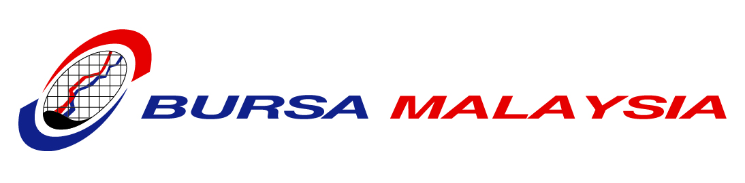

PRESS RELEASE
Kuala Lumpur/Chicago, 10/11 August 2009

Bursa Malaysia, CME GROUP to ESTABLISH STRATEGIC PARTNERSHIP IN DERIVATIVES MARKETS

KUALA LUMPUR 11 AUGUST/CHICAGO 10 AUGUST, 2009 – In line with the Prime Minister of Malaysia, Dato' Sri Najib Tun Abdul Razak’s acknowledgement on Bursa Malaysia Berhad’s (Bursa Malaysia) cooperative efforts with CME Group Inc (CME Group) to develop a robust derivatives market, the two exchanges announced today that they are working towards a collaboration involving trade matching services, product licensing and minor cross-equity investments. The CME Group equity stake will relate to Bursa Malaysia's derivatives business. Specific terms will be announced at a later date. Both parties announced that this initiative is subject to regulatory approval.

With this strategic partnership, CME Group will use Bursa Malaysia's RM-denominated CPO futures contract (FCPO) settlement prices, which will enable CME Group to develop a USD-denominated cash-settled CPO futures contract and its related options for listing on one of CME Group's US registered exchanges. This product is expected to be traded on CME Globex, which is CME Group's electronic trading platform.

Dato' Yusli Mohamed Yusoff, Chief Executive Officer of Bursa Malaysia, said, "The proposed collaboration is not only timely but also necessary as it would contribute to the overall growth of the Malaysian capital market. It is also aimed at globalising the Malaysian crude palm oil (CPO) futures market. Consequently, part of this proposed collaboration will enable Bursa Malaysia Derivatives to list its derivatives products on CME Globex. Through this collaboration, we expect the resulting expertise and knowledge transfer to further facilitate our goal for a robust derivatives exchange."

"This initiative, when implemented, will enable our customers from other markets to access Bursa Malaysia's derivatives markets and products on CME Globex, the leading and most widely distributed electronic trading platform in the world, further demonstrating our flexibility to operate in multiple jurisdictions for the benefit of customers worldwide," said Terry Duffy, Executive Chairman of CME Group.

"Our proposed strategic partnership with Bursa Malaysia will further enhance our globalisation efforts by facilitating our customers' efficient access to Bursa Malaysia's important markets," said Craig Donohue, Chief Executive Officer of CME Group. "This proposed partnership will allow us to continue to expand our transaction processing business opportunities, increase our presence in Asia as well as help our Malaysian partners grow their business."

-END-

About Bursa Malaysia
Bursa Malaysia Berhad is a public company limited by shares under the Companies Act 1965. Bursa Malaysia is an approved exchange holding company under Section 15 of the Capital Markets and Services Act 2007. Other companies in the Bursa Malaysia Berhad Group of companies include a stock exchange, a derivatives exchange, an off-shore international financial exchange, equity and derivatives clearing houses, a central depository, an information services provider and an Information Technology services provider.

About CME Group
As the world’s largest and most diverse derivatives marketplace, CME Group (www.cmegroup.com) is where the world comes to manage risk. CME Group exchanges offer the widest range of global benchmark products across all major asset classes, including futures and options based on interest rates, equity indexes, foreign exchange, energy, agricultural commodities, metals, weather and real estate. CME Group brings buyers and sellers together through its CME Globex® electronic trading platform and its trading facilities in New York and Chicago. CME Group also operates CME Clearing, one of the largest central counterparty clearing services in the world, which provides clearing and settlement services for exchange-traded contracts, as well as for over-the-counter derivatives transactions through CME ClearPort®. These products and services ensure that businesses everywhere can substantially mitigate counterparty credit risk in both listed and over-the-counter derivatives markets.

Issued by Bursa Malaysia Berhad and CME Group.

Media Contacts:

Bursa Malaysia Berhad
Geeta Balakrishnan
Tel : +603 2034 7374
E-mail : geetabalakrishnan@bursamalaysia.com

Delyana Nordin
Tel : +603 2034 7161
E-mail : delyana@bursamalaysia.com

CME Group
Allan Schoenberg,
Tel: 312.930.8189
Email: Allan.Schoenberg@cmegroup.com

Mary Haffenberg
Tel: 312.930.3435
Email: Mary.Haffenberg@cmegroup.com

